Anomaly Detection with Machine Learning at Scale

(Stream Analytix)

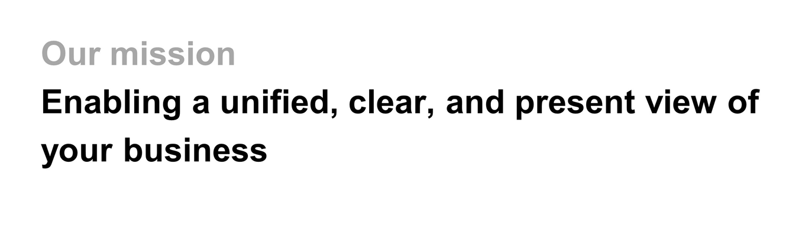

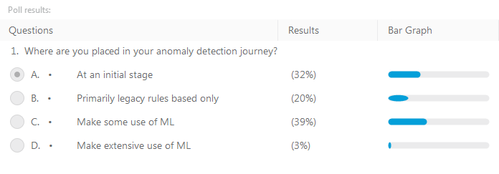

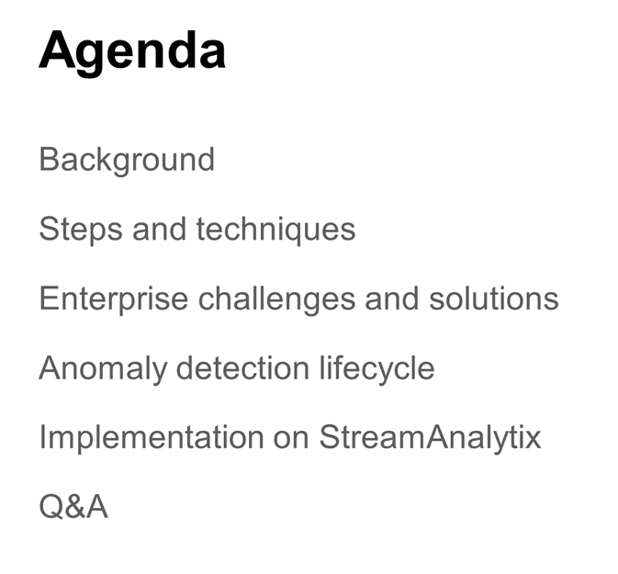



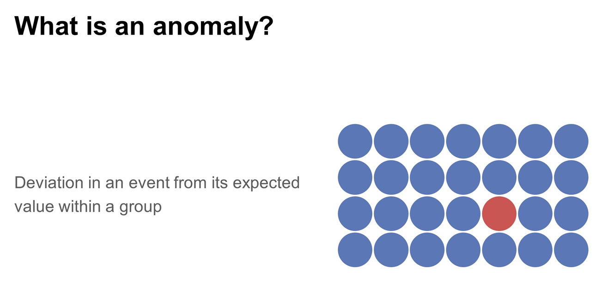

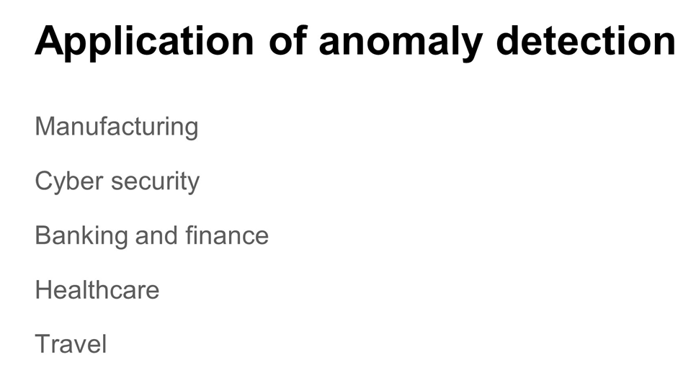

* Anomaly in motors, etc.
* Network Intrusions
* Banking – credit cards, etc.
* Healthcare – different body params (heart rate)
* Travel – Fare errors (when sold on multiple websites)

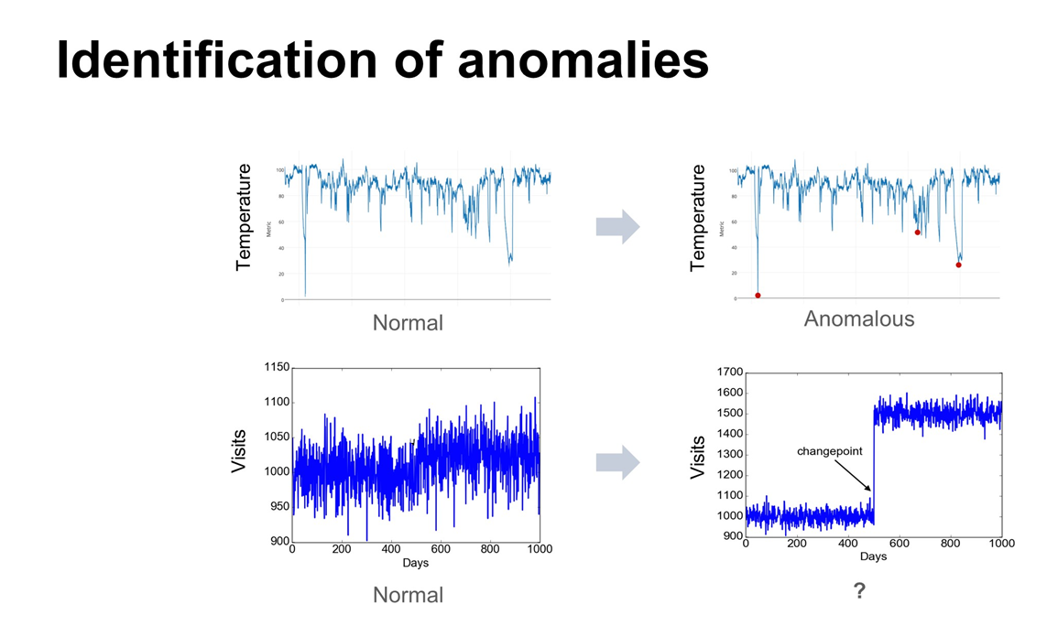

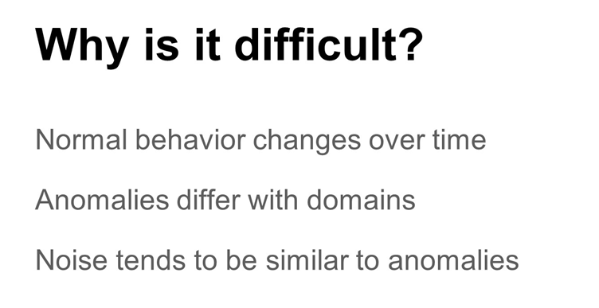

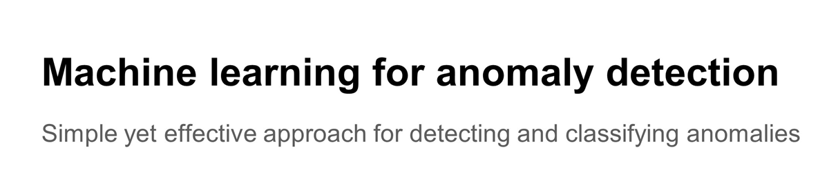

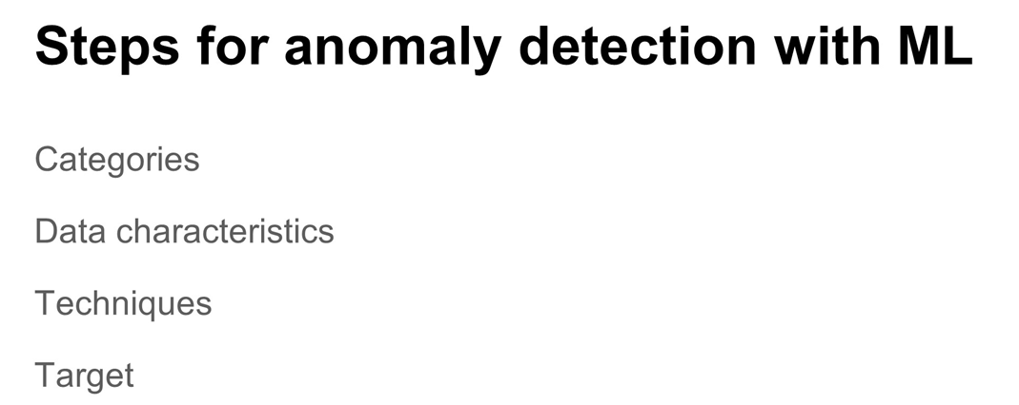

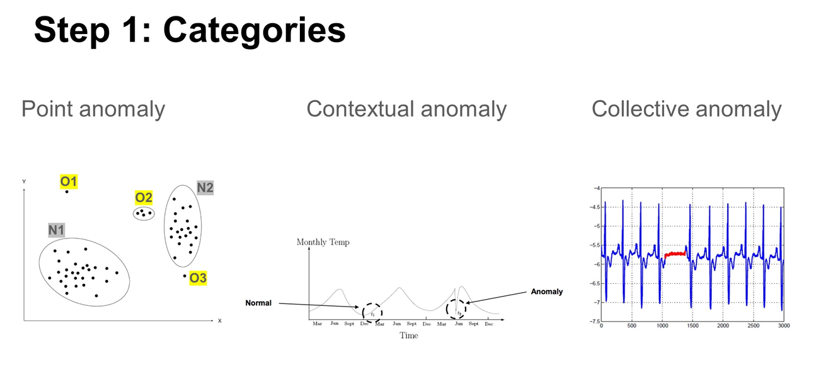

* Point Anomaly
* Contextual Anomaly
  + **For example time series anomaly**.
* Collective Anomaly
  + **Integrated over a period for example**.

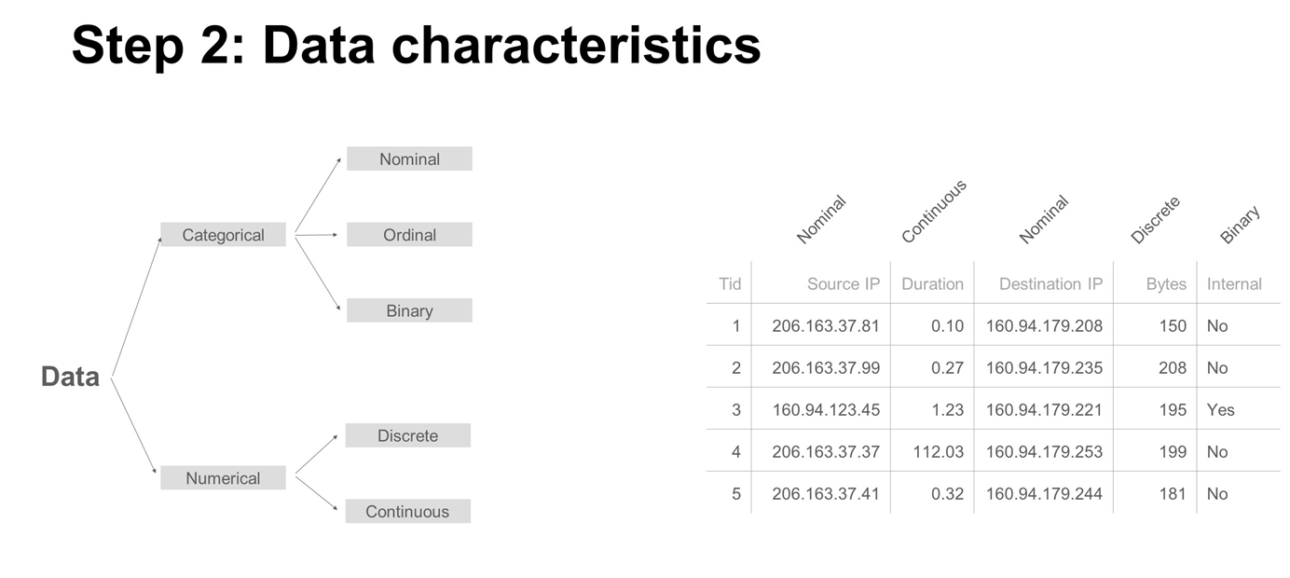

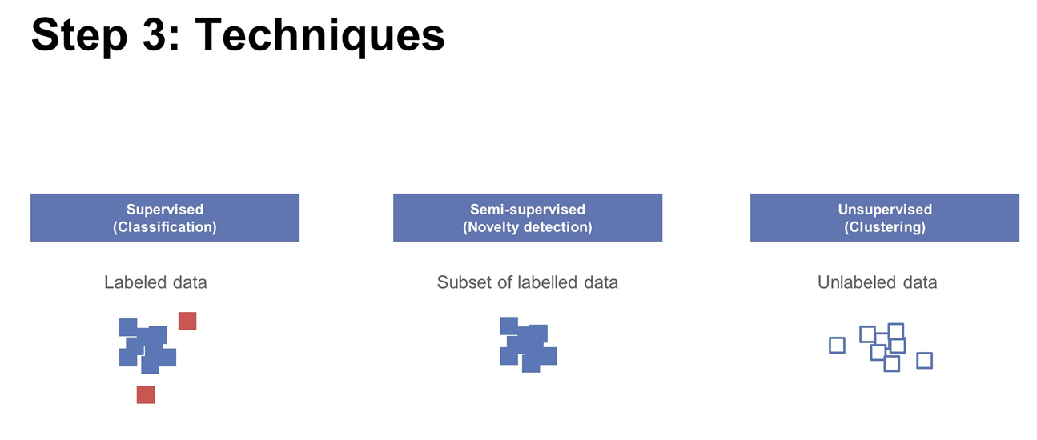

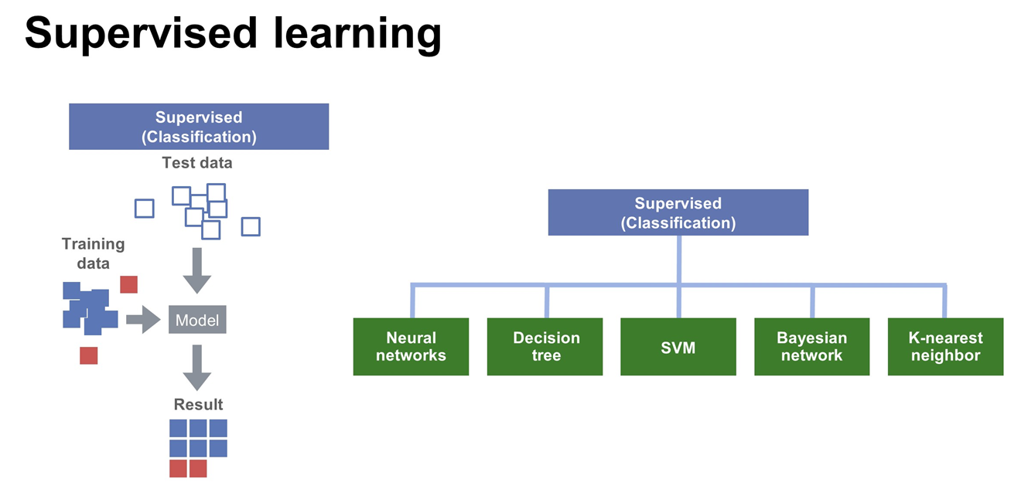

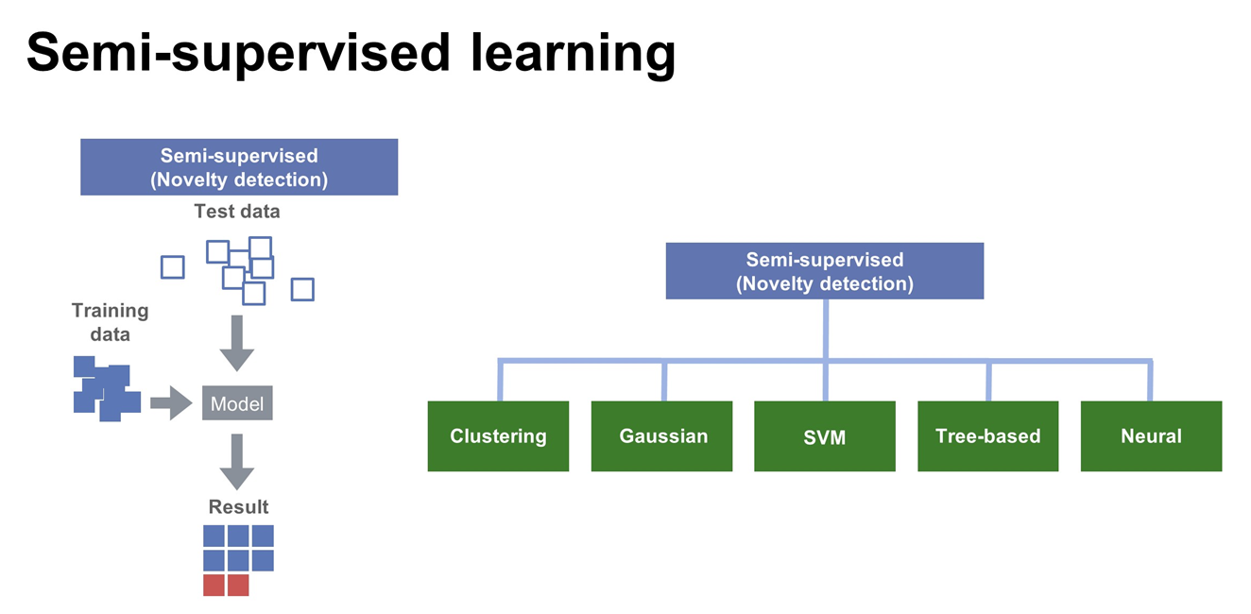

* **Only subset of labels are provided for training**

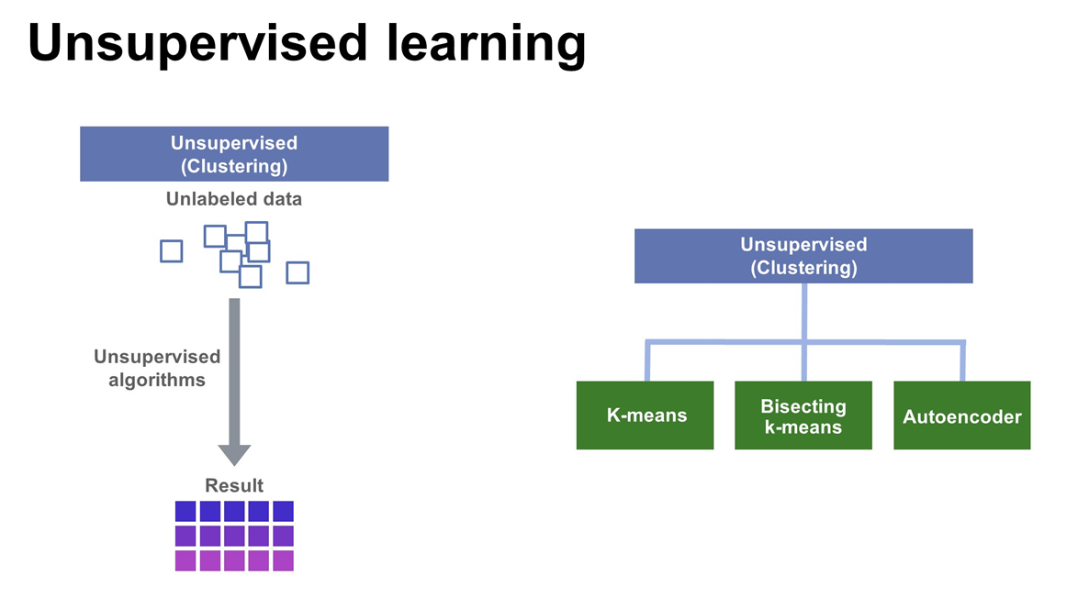

* **Bisecting K-Means = Hierarchical Clustering**

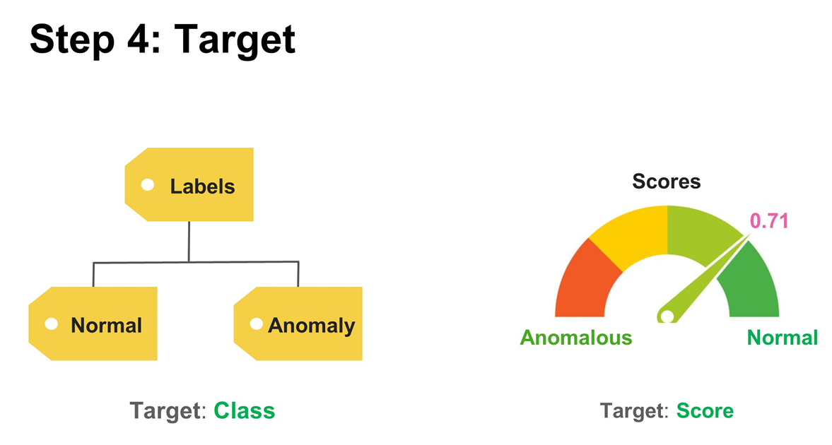

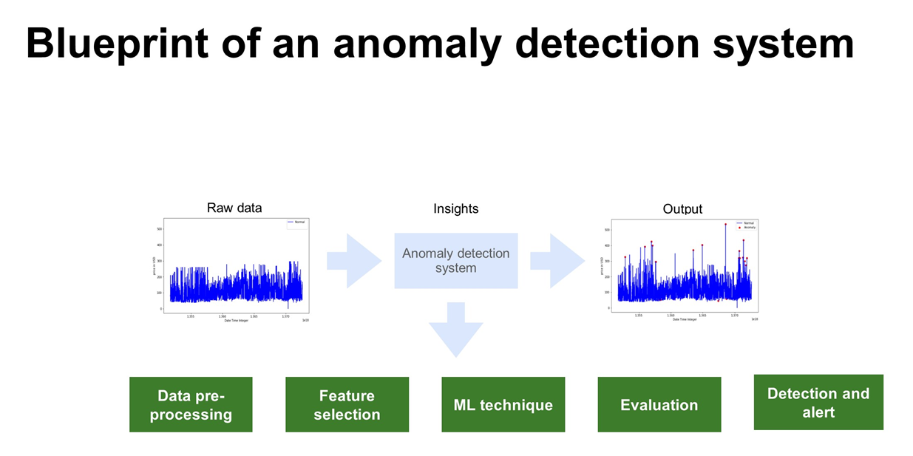

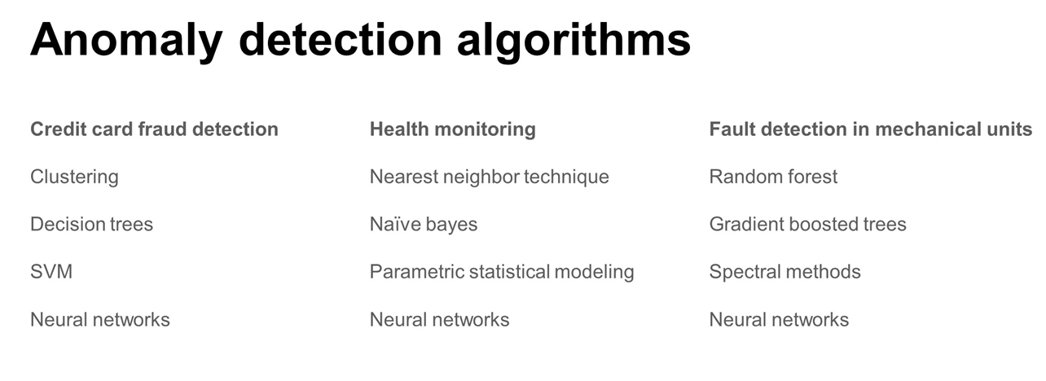

* Credit Card Fraud Detection:
  + Can have labels or no labels
    - With no labels – clustering
    - With clusters – supervised
* Health
  + Mostly supervised techniques
* Preventive Maintenance / Fault Detection
* **NOTE: NN’s can be used in all domains above**

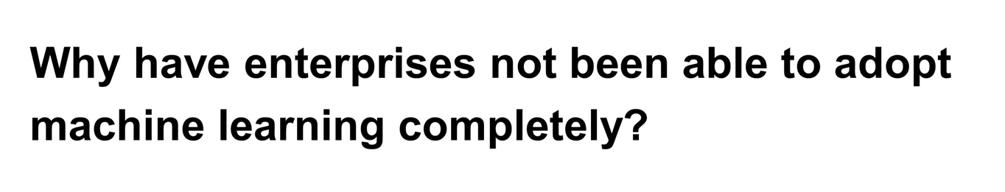

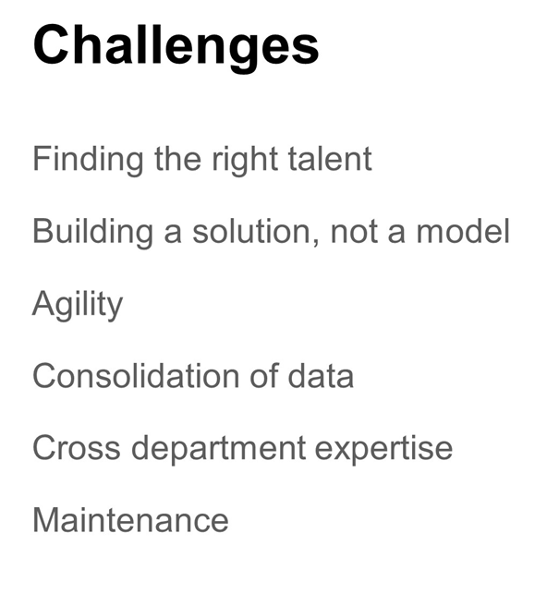

* **Agility:**
  + **Need to have many tuning parameters available that can be quickly changed in production, otherwise you have issues in production.**
* **Maintenance**
  + **Models get obsolete and need to be updated.**

